Flat Plate Collectors v. Evacuated Tubes – A Brief Overview

The 1st Rule of Solar – Use the Right Collector for the Job
There is no single collector that can be labeled ‘the most efficient,’ as the efficiency of collectors depends on what they are hooked up to. For seasonal swimming pool heating, an unglazed collector (e.g., Sunearth Oasis or polymer collectors) will beat out a flat plate collector at a fraction of the cost. An unglazed collector can pull off this feat because it is heating a pool at 80 °F when it is right about 80 °F outside. Under those conditions, the collector is running at ambient temperature and has no heat loss, therefore it does not need to be insulated.
When we start moving up in temperature it becomes more important to insulate the collector against losses. Whereas collectors on seasonal pools operate within 10-20 °F of ambient, domestic hot water (DHW) collectors are designed to run through the colder winters and at higher temperatures in a wide range of 25-125 °F above ambient, depending on location and season. The last application of thermal is in high-end process heat such as steam production or powering absorption chillers in the range of 150 °F above ambient. Efficiency plots of the various collector styles against collector inlet fluid temperature above ambient are shown in the figure below.
As discussed above, unglazed pool collectors dominate in low temperature applications 0-25 °F, flat plates hold sway in the mid-range of 25-125 °F, and evacuated tubes come into their own at the upper end at 125+ °F. This is the reason why no particular collector has dominated the entire thermal market; each collector has its own place.
As you move from unglazed to glazed and on to evacuated tubes you move up and up in price. Evacuated tubes could be used to heat swimming pools, but it would not make economic sense to do so given that an unglazed collector is 1/10th the cost and 30% more efficient. The same holds true, to a lesser degree, for using evacuated tubes to heat domestic hot water.
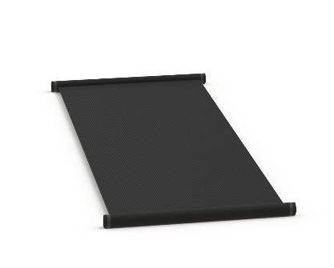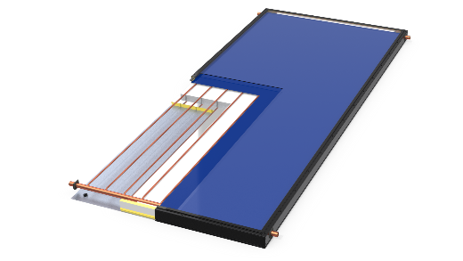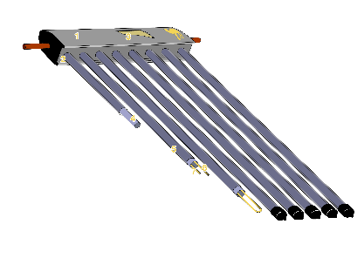
Unglazed Pool Collector Glazed Flat Plate Evacuated Tube
Photo Courtesy: SunEarth Photo Courtesy: SunEarth Photo Courtesy: Camel Solar
What About Low-Sun Conditions?
The performance charts above are only part of the efficiency equation. The other factor is the amount of
sunshine (i.e., irradiance) on the collector. The lower the amount of sun, the greater the advantage of glazed over unglazed and evacuated tube over glazed. However, this is a double-edged sword as doubling the efficiency at low sun doesn’t mean much if there wasn’t much sun to begin with. Actual collector output is the input times efficiency (Input x Efficiency), therefore if the input is nothing to start with but your efficiency is high, you still don’t get much out.

SRCC OG-100, the Final Word
Arguments could be made all day long about flat plates versus evacuated tubes and the benefits under various operating conditions. The table below was created using the data from SRCC OG-100 certification for SunEarth ThermoRay TRB-40 with a gross area of 40.90 ft² and SunMaxx Solar Thermopower VHP20 with a gross area of 37.42 ft². In order to have a correct comparison of two collector performances, the energy production per square foot was calculated.
As shown below, the evacuated tubes have higher performance over flat panel collectors in 3 instances, where the temperature difference is either high or very high and you have very little solar power coming from the sun to begin with. This translates to more annual savings for flat panel collector, since they have the highest output in all instances aside from low solar irradiance and extremely cold (below 20°F) ambient temperature conditions.
Based on SRCC OG-100 data | BTU/ft2/Day
Model: | TRB-40 | VHP20 | TRB-40 | VHP20 | TRB-40 | VHP20
Climate→ | High Radiation  (2000 Btu/ft².day) |  | Medium Radiation (1500Btu/ft².day) |  | Low Radiation  (1000 Btu/ft².day)
Category ↓
(Ti-Ta)
A (-9 ˚F) | 1,477 | 858 | 1,117 | 644 | 760 | 430
B (9 ˚F) | 1,347 | 837 | 988 | 623 | 631 | 409
C (36 ˚F) | 1,142 | 783 | 792 | 569 | 447 | 355
D (90 ˚F) | 780 | 623 | 447 | 414 | 147 | 203
E (144 ˚F) | 450 | 390 | 171 | 203 | 0 | 29

Ti = Temperature on Inlet fluid to Collector ; Ta = Ambient Temperature of Environment where the collector is installed.

